JOINS AND SET OPERATIONS
2520030300
G.NANDINI
STEP-1: Create a Data Base
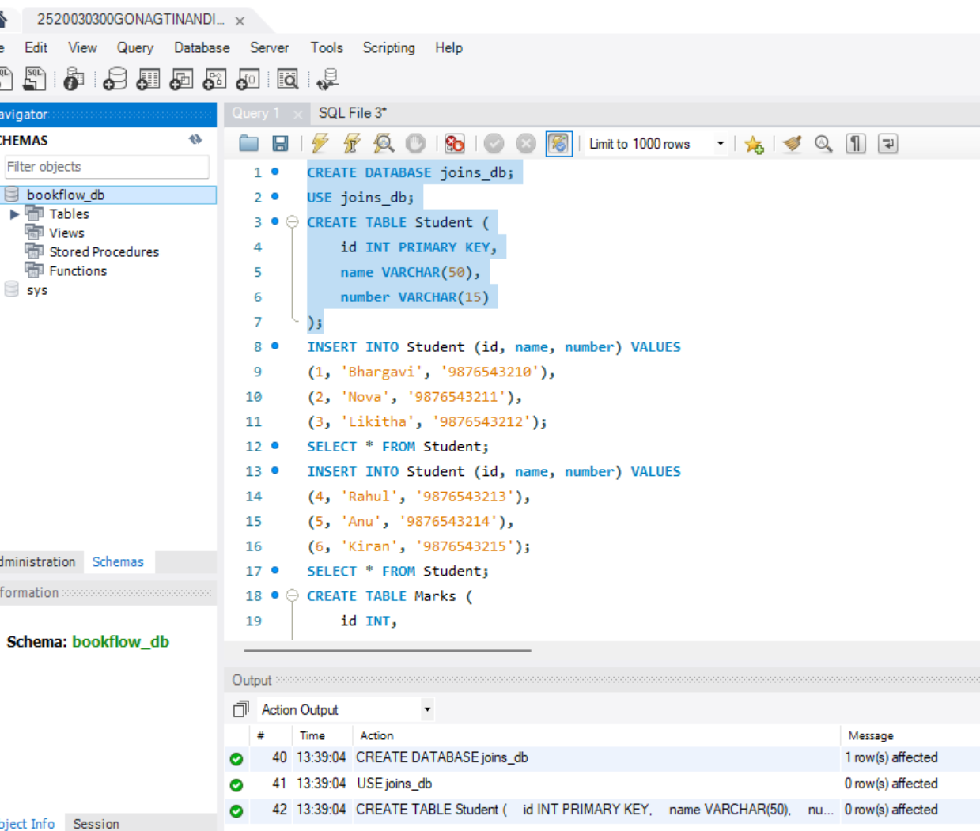
STEP-2: Create And Insert Table
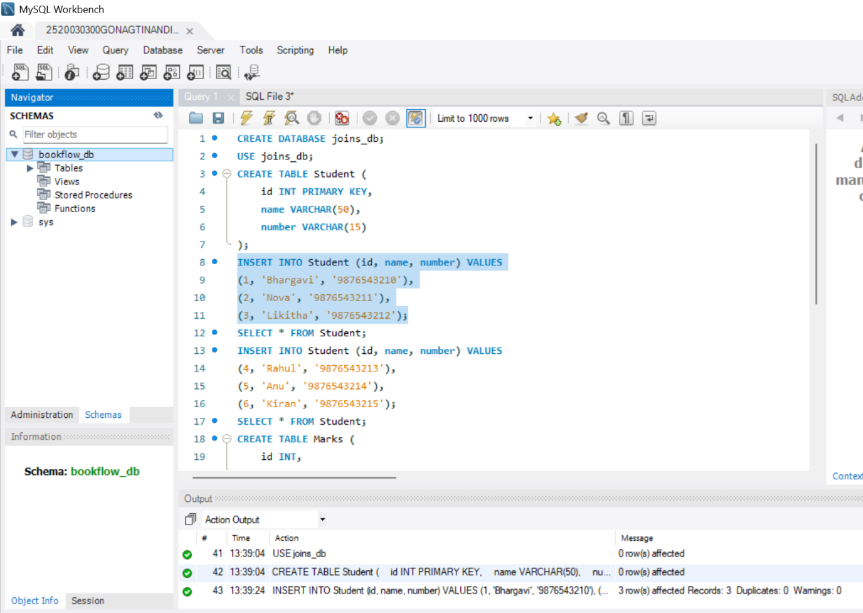
STEP-3: Cross Join
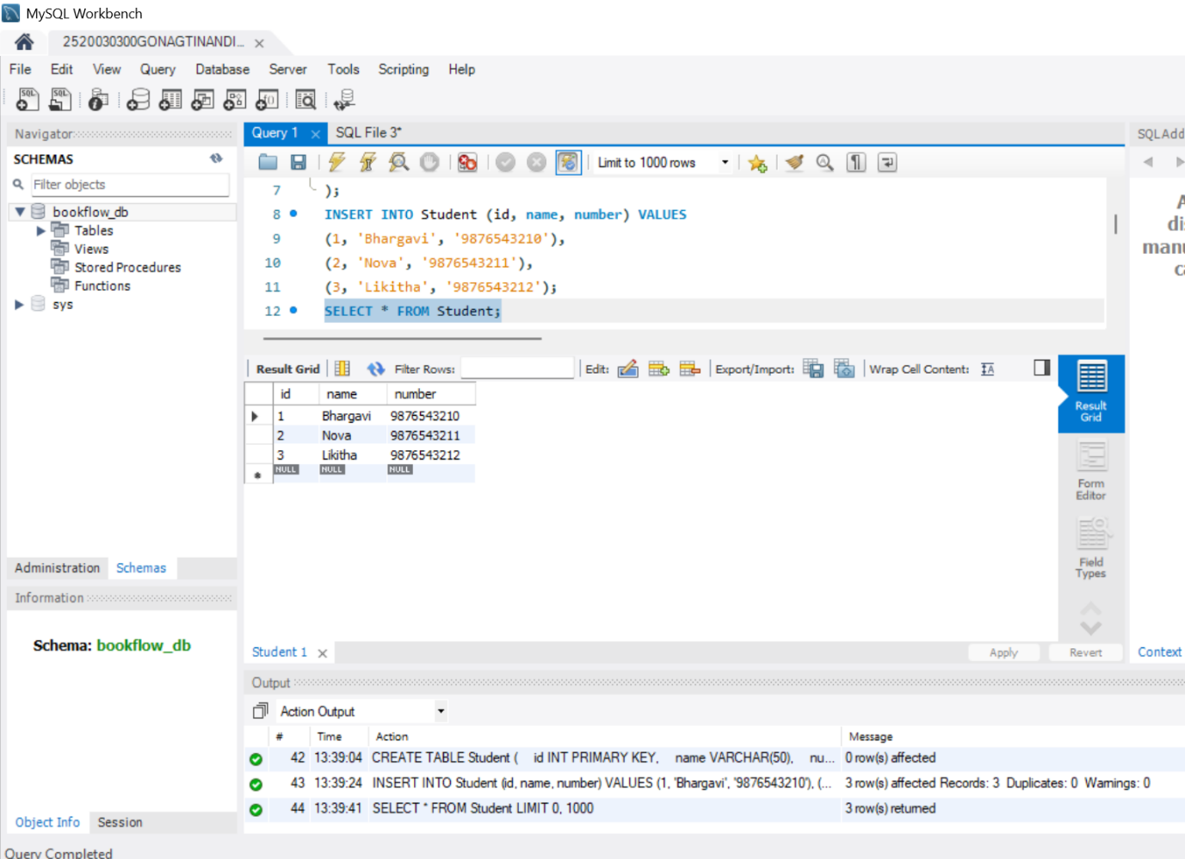
STEP-4: Inner Join
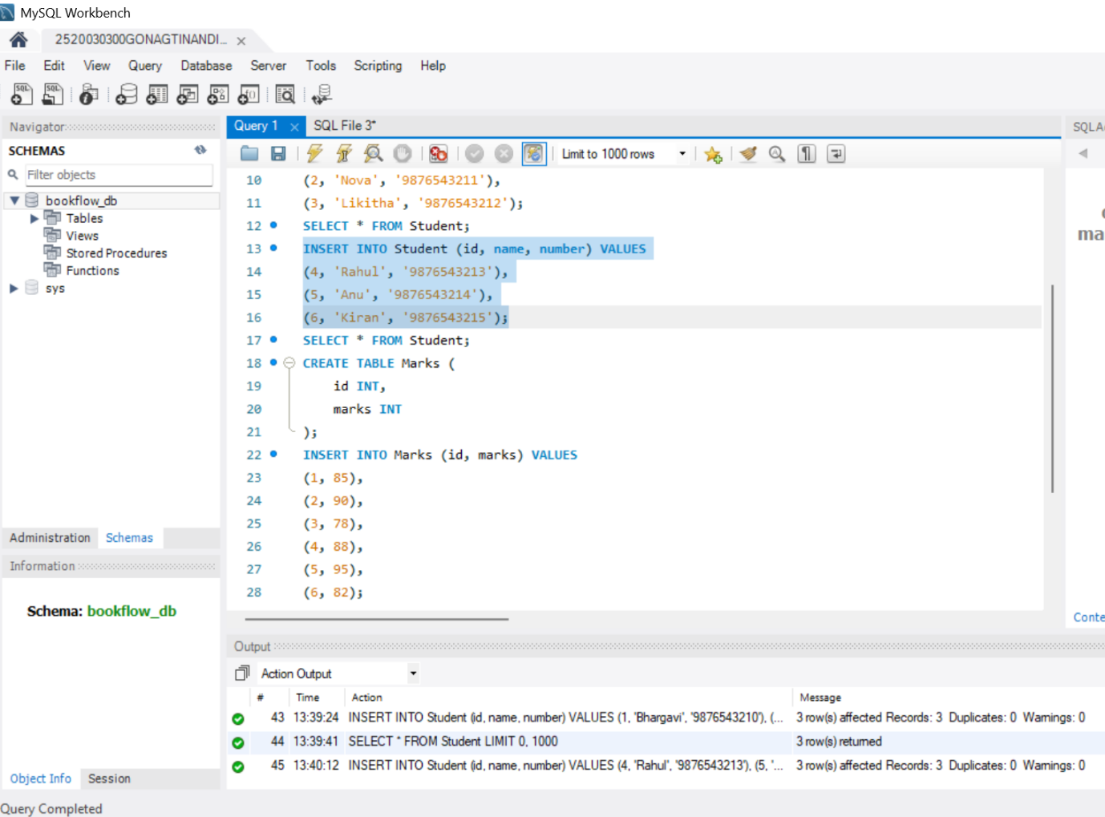
STEP-5: INNER JOIN with selected columns
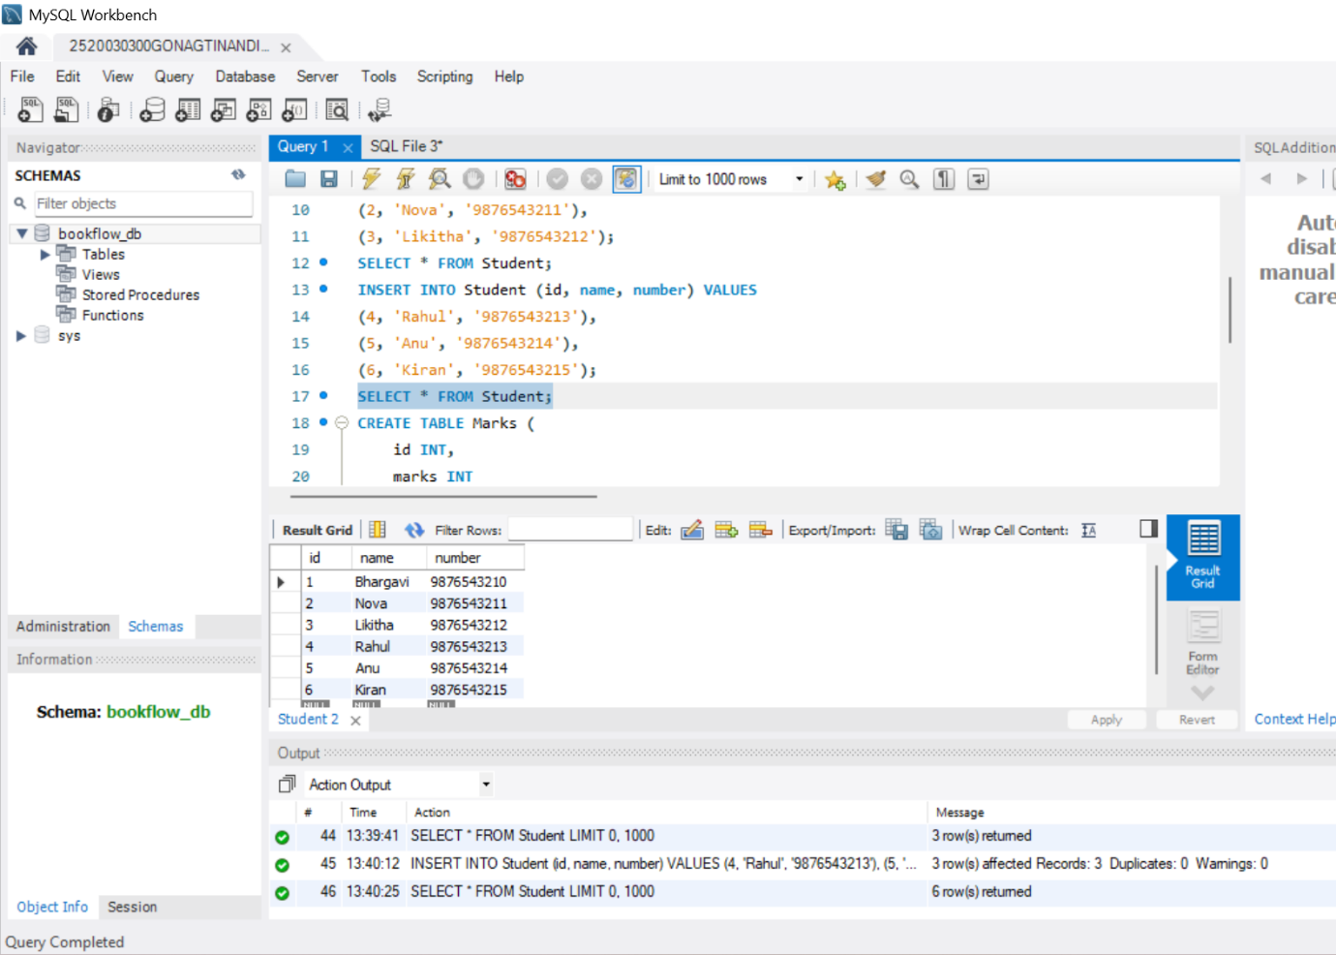
STEP-6: NATURAL JOIN
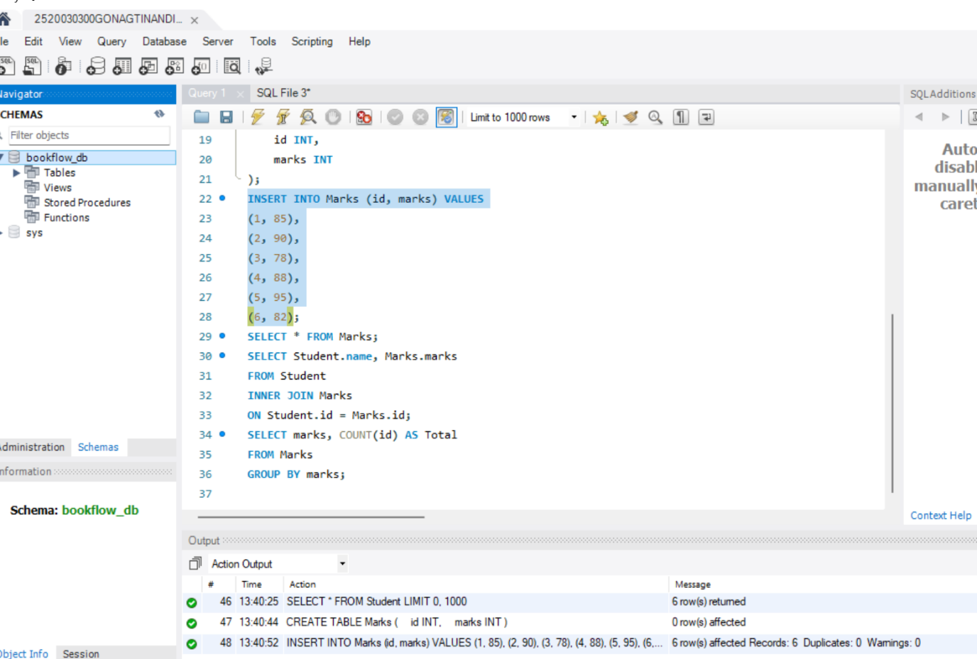
STEP-7: LEFT OUTER JOIN
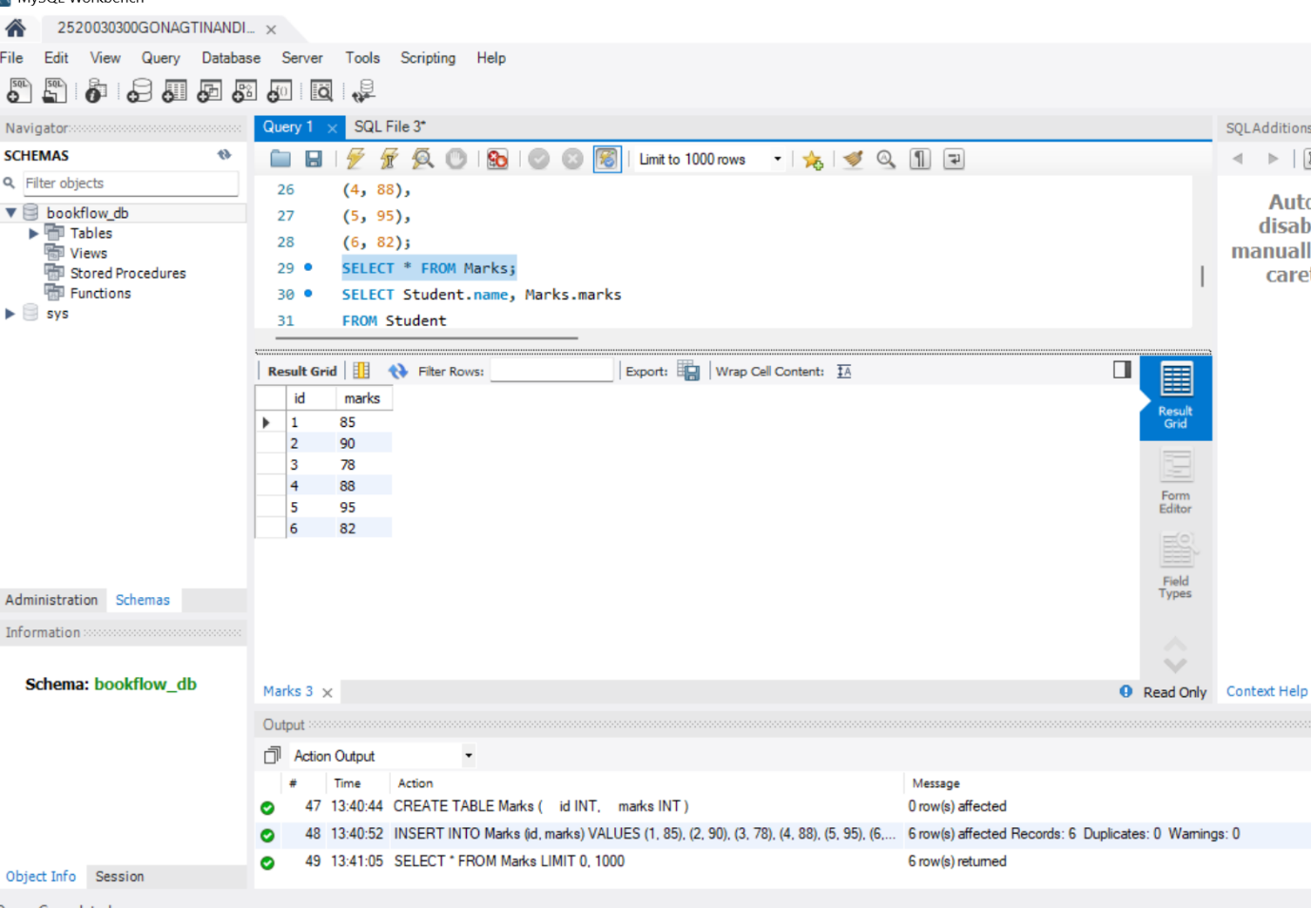
STEP-8: LEFT JOIN

STEP-9: RIGHT JOIN
